8 Fill and Put Hole in Form

If we change it to 2D mode, we can fill the Front.

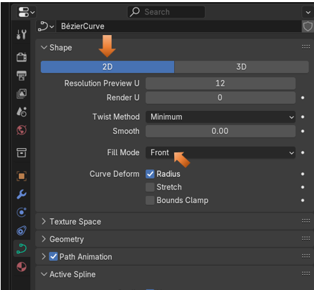

Now our shape is filled

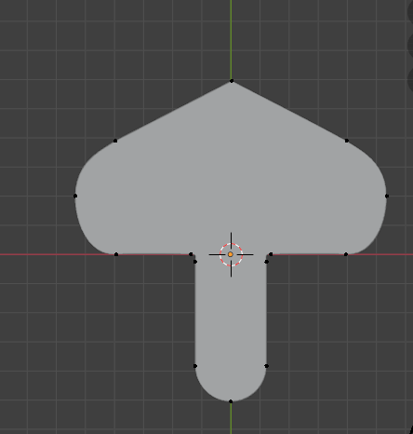

<https://www.youtube.com/watch?v=f53GvpTIO2w>

